
YEAR 12 CHEMISTRY – 3BCHE

TEST 4 - 2015

Organic Chemistry

Recommended time: 1 hour

This test is in two parts.

Part 1: Multiple choice style consisting of TEN (10) questions.
Each question is worth 1 mark.
Write your answers in the table provided below.
Attempt ALL Questions

Part 2: Short and/or Extended Answer questions
Write all answers in the spaces provided.
The marks allocated to each question are shown at the foot of each question.

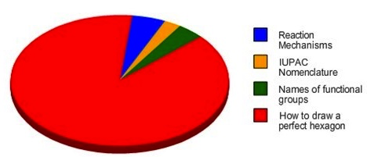


Things I learned in Organic Chemistry



PART 1: Multiple Choice (10 marks)

Write your answers to the following questions on the Multiple Choice Answer Sheet provided.

1. Linalool is a chemical found in many flowers and spice plants. It is extensively used in over 75% of household hygiene goods including shampoos, soaps and various lotions. The structure of Linalool is given below

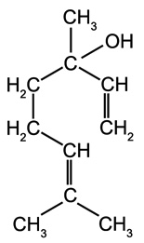
Linalool is
(a) an alcohol
(b) an aldehyde
(c) a carboxylic acid
(d) a ketone

2. The IUPAC systematic name for the compound whose structure is given below is
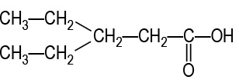
(a) 3,3-diethylpropanoic acid
(b) 3-ethylpentanal
(c) 3-ethylpentanoic acid
(d) 1-hydroxy-3-ethylpentanone

3. Concentrated sulfuric acid is an essential ingredient of esterification. Its function is to

- facilitate the oxidation of the alcohol to a carboxylic acid
- energise both reactants and products
- neutralise the basic (– OH) group of the alcohol
- provide the reaction with an alternative pathway that requires a lower amount of activation energy

4. Which of these substances can be oxidised to produce butanone?

(a) butan-1-ol
(b) butan-2-ol
(c) butanal
(d) cyclobutanol

5. Which of the following is/are isomers of butanoic acid?
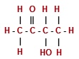
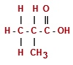
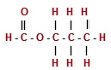
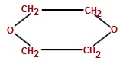

Structure 1 Structure 2 Structure 3 Structure 4

(a) Structure 3 only
(b) Structures 2 and 3 only
(c) Structures 2, 3 and 4 only
(d) All of them

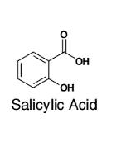
6. Salicylic acid is an organic substance used to help clear and prevent pimples and skin blemishes in people who have acne issues. Its structure is

Which of the following reagents would you expect to react with a solution containing fully dissolved salicylic acid under the conditions given below?

 | with acidified KMnO_{4(aq)} | with solid NaOH_{(s)} | with CH₃OH_{(l)} in the presence of sulfuric acid solution
(a) | Yes | Yes | Yes
(b) | Yes | No | Yes
(c) | No | Yes | No
(d) | No | No | No

7. The boiling point of a family of liquid halogenoalkanes are listed below.

Trifluoromethane CHF₃ -89ºC
Trichloromethane CHCl₃ 61ºC
Tribromomethane CHBr₃ 150ºC
Triiodomethane CHI₃ 330ºC

The increase in boiling points down the group is due to an increase in the strength of

- covalent bonds
- dispersion forces
- dipole-dipole attraction
- hydrogen bonds
8. The following diagram shows the structure of decanoic acid (or capric acid).
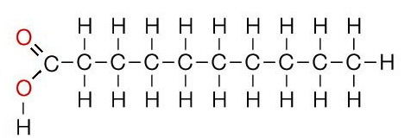

The name capric acid is derived from the Latin "caper / capra" (goat) because the sweaty, unpleasant smell of the compound is reminiscent of goats. (Wikipedia)

Based on the structure shown above, it can be predicted that this molecule is

(a) equally soluble in both liquid decane (C₁₀H₂₂) and water
(b) more soluble in water than liquid decane (C₁₀H₂₂)
(c) more soluble in liquid decane (C₁₀H₂₂) than in water
(d) none of the above

9. A compound associated with the smell or flavour of pineapples has the following structural formula
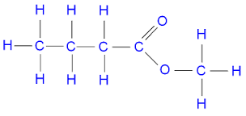

To produce this compound in the laboratory you would react:

(a) methanol and butanoic acid in the presence of concentrated sulfuric acid.
(b) 1-butanol and methanol in the presence of concentrated sulfuric acid.
(c) 1-butanol and methanoic acid in the presence of concentrated sulfuric acid.
(d) methanol and methanoic acid in the presence of concentrated sulfuric acid.

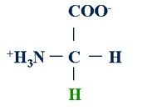
10. Glycine is an amino acid with the formula, H₂NCH₂COOH. In aqueous solution, glycine forms the glycine zwitterion with the structural formula:

(Glycine zwitterion)

The equilibrium reaction of glycine zwitterion in a sealed system at a certain pH is as follows:

⁺H₃NCH₂COO⁻_{(aq)} + OH⁻_{(aq)} H₂NCH₂COO⁻_{(aq)} + H₂O_{(l)}
(glycine zwitterion) (glycinate anion)

The equilibrium concentration of the glycinate anion (H₂NCH₂COO⁻) can be increased by:

(a) adding a small amount of water
(b) adding a small amount of hydrochloric acid solution
(c) adding a small amount of sodium hydroxide powder
(d) reducing the volume of the sealed system

MULTIPLE CHOICE ANSWER SHEET

/ 40

Name: _____________________________________________________

Teacher: _____________________________________________________

Instruction

For each question shade the box to indicate your answer.
Use only a blue or black pen to shade the boxes.

For example, if b is your answer: a b c d

If you make a mistake, place a cross through that square then shade your new answer.
Do not erase or use correction fluid.

For example, if b is a mistake and d is your answer: a b c d

If you then want to use your first answer b, cross out d and then circle b.

a b c d

Marks will not be deducted for incorrect answers. No marks will be given if more than one answer is completed for

Questions 1-10

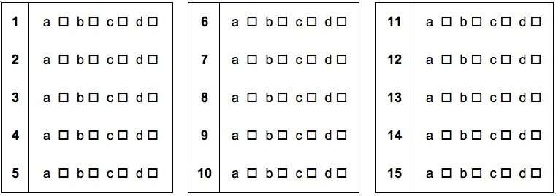

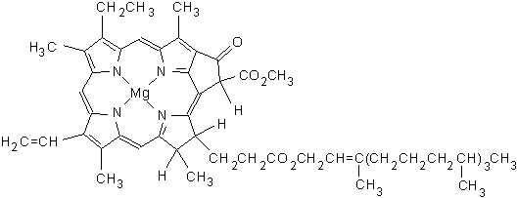

PART 2 : Short Answers (30 marks)

Write your answers in the space provided.

1. Complete the following table by naming or drawing the structural formula

Structural formula | Name
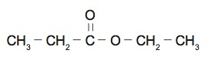

 | 3-chlorobutan-2-ol
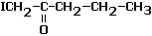

(3 marks)

2. Apart from acidified sodium permanganate (KMnO₄) and potassium dichromate (K₂Cr₂O₇) solutions, chromic acid (H₂CrO₄) may also be used to oxidise alcohols.

In an experiment, Timmy added a small volume of chromic acid solution to a 5 mL sample of warm
butan-1-ol and the reaction allowed to go to full completion. The colour of the acid solution was observed to change from yellow to deep green. As the oxidation number of the chromium atom in chromic acid is the same as that of potassium dichromate, it can be assumed that the resultant green colour was due to the presence of chromium (III) ions in the final mixture.

Use the information provided to complete the table below:

Oxidation half equation

Reduction half equation

Overall redox equation

(3 marks)
3. Recent research being done in Australia has led to the conclusion that people who suffer from Chronic Fatigue Syndrome (CFIDS), especially those with more neurological symptoms, may actually have a treatable amino acid deficiency. At the 1998 CFIDS conference in Sydney, doctors from Newcastle University in Callaghan, Australia, presented their intriguing discovery that a substantial number of CFIDS patients have a deficiency in the amino acid, serine.

One form of serine, L-serine has the structural formula

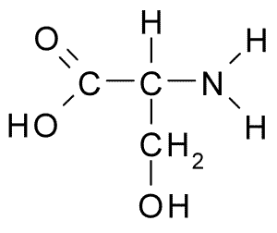

(a) On the structural formula above, circle and name any two (2) functional groups.
(2 marks)

(b) State the likely observation when a few drops of acidified potassium permanganate is added to a small sample of L-serine that has been heated to an appropriate temperature.

____________________________________________________________________________
(1 mark]

(c) In favourable conditions, L-serine, whose chemical formula is HO-CH₂-CH(NH₂)-COOH, can act as a Lowry-Bronsted acid. Write a suitable chemical equation to show this characteristic.

(1 mark)
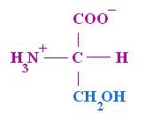
(d) In aqueous solution, L-serine forms a zwitterion with the structure:

(i)

The L-serine zwitterion above can form two (2) different ions:


COOH
(ii) H₂N
(iii)

Which of the structures (i), (ii) or (iii) is mostly found in

Alkaline or basic solutions

Acidic solutions

(2 marks)
4. For the following pair of substances, provide details of a chemical test that would allow the two substances to be distinguished from one another. Equations are not required.

Substances | Chemical test | Observations
liquid ethanal (CH₃CHO)  and  ethanoic acid (CH₃COOH) |  | with ethanal :  with ethanoic acid :

(3 marks)

5. At atmospheric pressure, the boiling point of propanone (or acetone), commonly used as a nail polish remover, is 56ºC while propan-1-ol, a known industrial solvent, boils at 97ºC.

Use your knowledge of bonding and intermolecular forces to explain these observations. You may find the use of suitable diagrams useful in your explanation.

__________________________________________________________________________________

__________________________________________________________________________________

__________________________________________________________________________________

__________________________________________________________________________________

__________________________________________________________________________________

__________________________________________________________________________________

__________________________________________________________________________________

__________________________________________________________________________________

(3 marks)

6. Elemental analysis of powder found in an abandoned farmhouse shows the presence of carbon, hydrogen, phosphorus and oxygen.

A 5.21 g sample of powder produces 6.32 g of carbon dioxide and 3.24 g of water when combusted completely in excess oxygen gas.

A second, 3.15 g, sample of the same powder is treated with excess nitric acid to convert all of the phosphorus to phosphate ions (PO₄³⁻). The resulting solution is treated with excess calcium nitrate solution to produce 3.37 g of calcium phosphate (Ca₃(PO₄)₂) precipitate.

- Determine the empirical formula of the powder. (11 marks)

(b) Further analysis of the powder reveals the molar mass of the powder to be 290.18 gmol⁻¹. What is the molecular formula of this powder? (1 mark)



